H. M. Faisal (03455275108) Computer Organization and Assembly Language (CS-530)

Lesson Plan 2

Objectives: The main objectives are: (a) Number System; (b) Conversion; (c) Operations; (d) Compliment.

Content: Number system is a way to represent numbers. We are used to using the base-10 number system, which is also called decimal. Other common number systems include base-16 (hexadecimal), base-8 (octal), and base-2 (binary).

In this lecture, I’ll explain what these different systems are, how to work with them, and why knowing about them will helpful and when they need.

Methods: For every topic, I will first provide the concept and example, then I will request some student to come to the board and with the help of class solve some new examples. This process will not only give them confidence of solving on their own, but will also encourage them to openly discuss any complications they face.

Resources: Besides the lecture handout, this lesson will draw from the following Text books: Assembly Language Programming and Organization of the IBM-PC, Ytha Yu and Charles Marut.

Evaluation: In this lecture I will not be using any formal evaluation process. I will be using informal techniques to monitor if the students have absorbed the material or not: (i) By making the students step up to the board and solve some examples. (iii) By judging the class interaction, which is a clear indicator of their interest.

Assignment: Give them a home assignment on conversion and compliment.

Time  Plan  (min) | Contents of Lecture | Lecture  Strategy  (Remarks)
10 mins | Number System:  - Binary Number System:  In the binary number system, the base is two and there are only two digits, 0 and 1.  For example, the binary string 11010 represents the number:  1 x 2⁴ + 1 x 2³ + 0 x 2² + 1 x 2¹ + 0 x 2⁰ = 26  The base two is represented in binary as 10.  - Hexadecimal Number System:  The hexadecimal (hex) system is a base sixteen system. The hex digits are 0, 1, 2, 3, 4, 5, 6, 7, 8, 9, A, B, C, D, E, and F. The hex letters A through F denote numbers ten to fifteen, respectively. After F comes the base sixteen, represented in hex by 10.  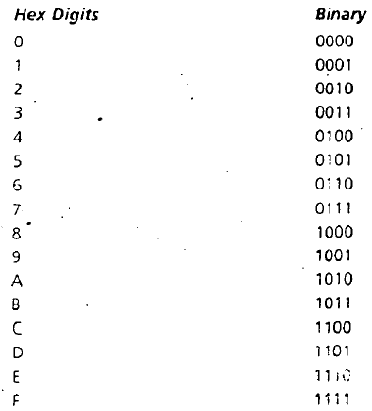

Time  Plan  (min) | Contents of Lecture | Lecture  Strategy  (Remarks)
10  mins | 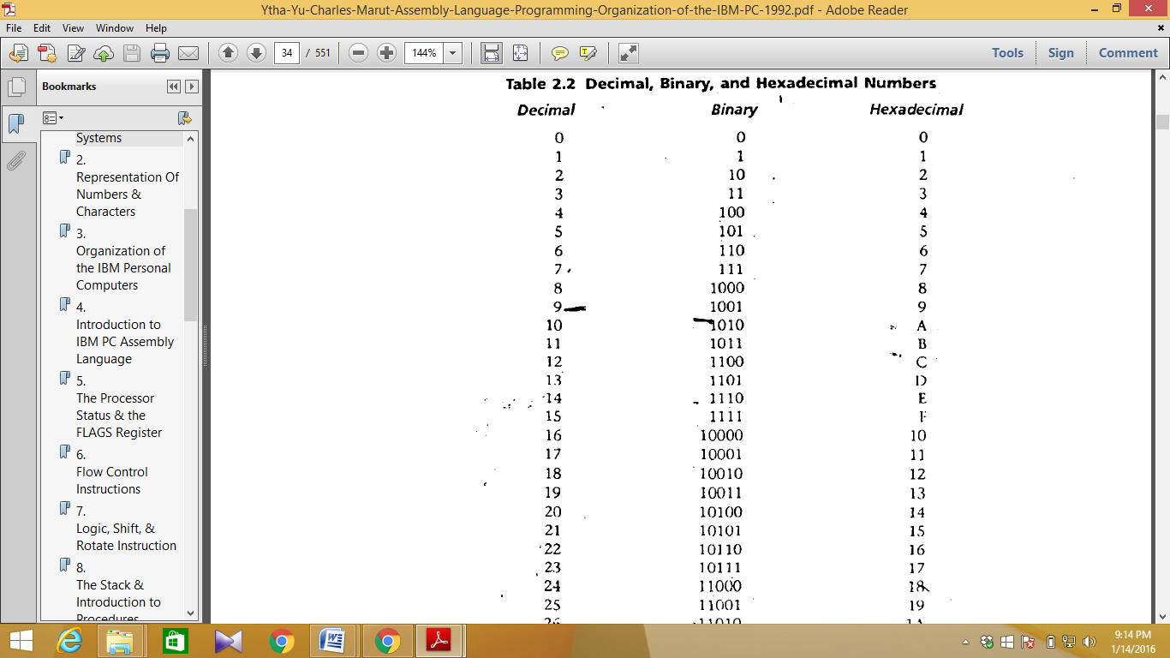  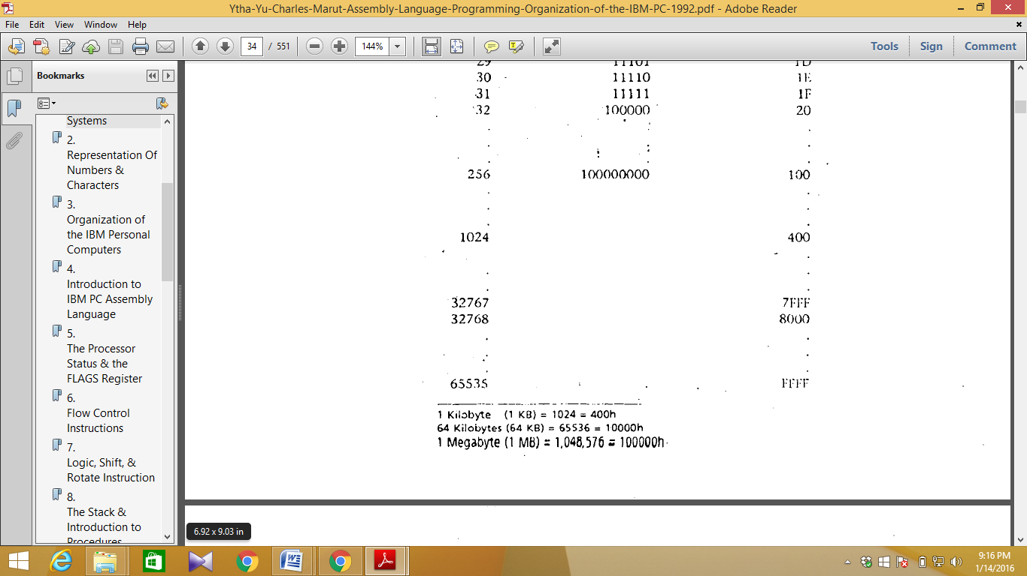

Time  Plan  (min) | Contents of Lecture | Lecture  Strategy  (Remarks)
10  mins | Conversion:  - Converting Binary and Hex to Decimal:  Consider the hex number 82AD. It can be written as:  8A2Dh = 8 x 16³ +A x 16² + 2 x 16¹ +D x16⁰  = 8 x 16³ +10 x 16² + 2 x 16¹ + 13 x 16⁰ = 35373d  Similarly, the binary number 11101 may be written as:  11101 b = 1 x 2⁴ + 1 x 2³ + 1 x 2² + 0 x 2¹ + 1 x 2⁰ = 29d  This gives one way to convert a binary or hex number to decimal, but an easier way is to use nested multiplication. For example:  8A2D = 8 x 16³ + A x 16² + 2 x 16¹ + D x16⁰  = ((8 x 16 + A) x 16 + 2) x 16 + D  = ((8 x 16 + 10) x 16 + 2) x 16 + 13  = 35373d  - Converting Decimal to Binary and Hex:  Suppose we want to convert 11172 to hex. The answer 2BA4h may be obtained as follows.  First, divide 11172 by 16. We get a quotient of 698 and a remainder of 4. Thus:  11172 = 698 x 16 + Ah  The remainder 4 is the unit's digit in hex representation of 11172. Now divide 698 by 16. The quotient is 43, and the remainder is 10 = Ah. Thus:  698 = 43 x 16 + Ah  The remainder Ah is the sixteen's digit in the hex representation of 11172. We just continue this process, each time dividing the most recent quotient by 16, until we get a 0 quotient. The remainder each time is a digit in the Hex representation of 11172. Here are the calculations:  11172 = 698 x 16 + 4  698 = 43 x16 + 10(Ah)  43 = 2 x 16 + 11(Bh)  2 = 0 x 16 + 2  Now just convert the remainders to hex and put them together in reverse order to get 2BA4h.  This same process may be used to convert decimal to binary. The only difference is that we repeatedly divide by 2.  - Conversions between Hex and Binary:  To convert a hex number to binary, we need only express each hex digit in binary.

Time  Plan  (min) | Contents of Lecture | Lecture  Strategy  (Remarks)
10  mins | Operations:  - Addition:  Consider the following decimal addition:  2546 + 1872 = 4418  To get the unit's digit in the Sum, we just compute 6 + 2 = 8. To get the ten's digit, compute 4 + 7 = 11. We write down 1 and carry 1 to the hundred's column. In that column we compute 5 + 8 + 1 = 14. We write down 4 and carry 1 to the last column. In that column we compute 2 + 1 + 1 = 4 and write it down and the sum is complete.  Hexadecimal Addition Table  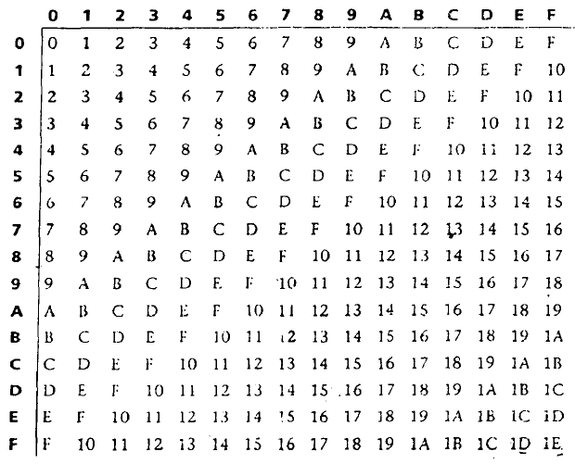  Binary Addition Table  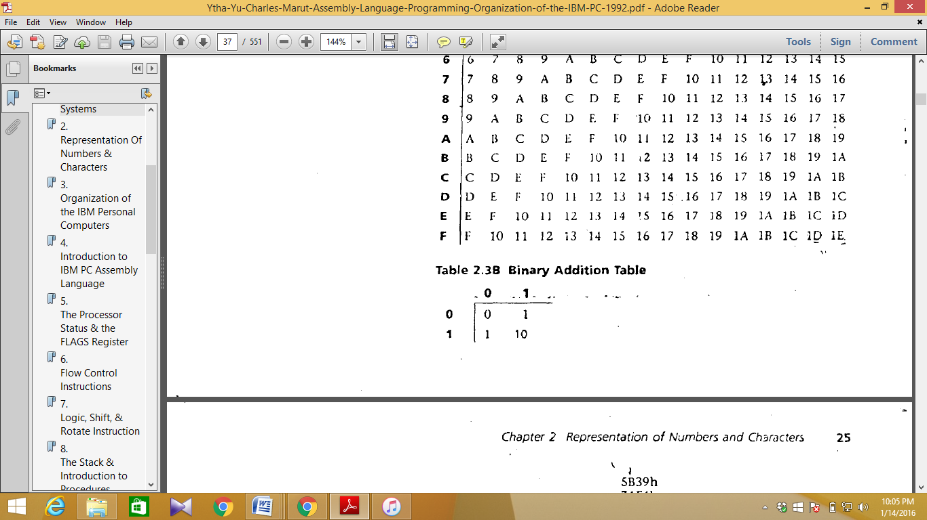

Time  Plan  (min) | Contents of Lecture | Lecture  Strategy  (Remarks)
10  mins | • How Integers Are Represented in the Computer?  We’ll need to refer to two particular bits in a byte or word: the most significant bit, or MSB, is the left most bit. In a word, the MSB is bit 15; in a byte, it is bit 7. Similarly, the least significant bit, or LSB, is the rightmost bit; that is, bit 0.  Unsigned Integers:  An unsigned integer is an integer that represents a magnitude, so it is never negative. Unsigned integers are appropriate for representing quantities that can never be negative, such as addresses of memory locations, counters, and ASCII character codes (see later). Because unsigned integers are by definition nonnegative, none of the bits are needed to represent the sign, and so all 8 bits in a byte, or 16 bits in a word, are available to represent the number.  The largest unsigned integer that can be stored in a byte is 11111111 = FFh = 255. This is not a very big number, so we usually store integers in words. The biggest unsigned integer a 16-bit it word can hold is 1111111111111111 = FFFFh = 65535. This is big enough for most purposes.  If not, two or more words may be used. Note that if the least significant bit of an integer is 1, the number is odd, and it's even if the LSB is 0.  Signed Integers:  A signed integer can be positive or negative. The most significant bit is reserved for the sign: 1 means negative and 0 means positive. Negative integers are stored in the computer in a special way known as two's complement.  Complement:  - One's Complement:  The one's complement of an integer is obtained by complementing each bit; that is, replace each 0 by 1 and each 1 by 0. In the following, we assume numbers are 16 bits.  Find one’s compliment of 5.  Ans: 11111010b  - Two's Complement:  To get the two's complement of an integer, just add 1 to its one's complement.
Ans: 11111011b

Time  Plan  (min) | Contents of Lecture | Lecture  Strategy  (Remarks)
10  mins | Exercise:  - Convert 82ADh to decimal.  Ans: 35373d  - Convert 11101b to decimal.  Ans: 29d  - Convert 2BD4h to decimal.  Ans: 11220d  - Convert 95 to binary.  Ans: 1011111b  - Convert 2B3Ch to binary.  Ans: 0010101100111100b  - Convert 1110101010b to hex.  Ans: 3AAh  - Add 3546d and 1872d.  Ans: 5418d / 3CF61h  - Add 5B39h and 7AF4h.  Ans: D62Dh  - Add 100101111b and 110110.  Ans: 101100101b  - Subtract 7283d from 9145d.  Ans: 1862d  - Subtract BA94h from D26Fh.  Ans: 17DBh  - Subtract 0111b from 1001.  Ans: 10b  - Find one’s compliment of 5.  Ans: 11111010b

Time  Plan  (min) | Contents of Lecture | Lecture  Strategy  (Remarks)
10  mins | - Find two’s compliment of 5.  Ans: 11111011b  - Find two’s compliment of the two’s compliment of 5.  Ans: 101b  - Suppose AX contains 5ABCh and BX contains 21FCh. Find the difference of AX minus BX by using complementation and addition.  Ans: 10011100011000000b=38C0h  - Suppose AX contains FE0Ch. Give the unsigned and signed decimal interpretations.  Ans: signed=500  Unsigned=65036  - Show how the character string “RG 2z” is stored in memory, starting at address 0.  Ans:  - In many applications, it saves time to memorize the conversions among small binary, decimal, and hex numbers. Fill in the blanks in the following table:  Binary Decimal Hex  1001b 9 9h  1010b 10 Ah  1101b 13 Dh  1100b 12 Ch  1110b 14 Eh  1011b 11 Bh  - Convert the following binary and hex numbers to decimal:  - 1110b=14d  - 100101011101b=2397d  - 46Ah=1130d  - FAE2Ch=1027628d
  Address | Contents of Bytes
  0 | 01010010
  1 | 01000111
  2 | 00100000
  3 | 00110010
  4 | 01111010

Time  Plan  (min) | Contents of Lecture | Lecture  Strategy  (Remarks)
10  mins | - Give the unsigned and signed decimal interpretations of each of the following 16-bit or 8 bit numbers.  Signed unsigned  - 7FFEh 32766d 32766d  - 8543h 34115d -31421d  - FEh -2d -254d  - 7Fh 7d 7d  - Show how the decimal integer -120 would be represented  - In 16 bits=1111111110001000b  - In 8 bits=10001000b  - For each of the following decimal numbers, tell whether it could be stored (a) as a 16-bit number (b) as an 8-bit number.  - 32767=16 bit  - -40000= out of range  - 65536= out of range  - 257= 16 bit  - -128= 8 bit  - For each of the following 16-bit signed numbers, tell whether it is positive or negative.  - 1010010010010100b=negative  - 78E3h=positive  - CB33h=negative  - 807Fh=negative  - 9AC4h=negative  - If the character string “$12.75” is being stored in memory starting at address 0, give the hex contents of bytes 0-5.  Ans:  - Translate the following secret message, which has been encoded in ASCII as 41 74 74 61 63 6B 20 44 61 77 6E.  Ans: Attack Dawn.
  Address | Contents of Bytes
  0 | 00100100
  1 | 00110001
  2 | 00110010
  3 | 00101110
  4 | 00110111
  5 | 00110101

Time  Plan  (min) | Contents of Lecture | Lecture  Strategy  (Remarks)
- Suppose that a byte contains the ASCII code of an uppercase letter. What hex number should be added to it to convert it to lower case?
Ans: 20h

- Suppose that a byte contains the ASCII code of a decimal digit; that is, “0” . . . “9”. What hex number should be subtracted from the byte to convert it to the numerical form of the characters?
Ans: 30h

